The heart wall is composed of:
A. Epicardium
B. Myocardium
C. Endocardium
D. All of these
ANSWER: D
The _________is a thin serous membrane comprising of the smooth outer surface of the heart
A. Epicardium
B. Myocardium
C. Endocardium
D. All of these
ANSWER: A
The thick middle layer of the heart, the___________, is composed of cardiac muscle cells and is responsible for the ability of the heart to contract.
A. Epicardium
B. Myocardium
C. Endocardium
D. All of these
ANSWER: B
The smooth inner surface of the heart chambers is the__________, which consists of simple squamous epithelium over a layer of connective tissue.
A. Epicardium
B. Myocardium
C. Endocardium
D. All of these
ANSWER: C
The ___________has thinner walls than the ____________in a ratio of 1:3
A. Left ventricle, right atrium
B. Right ventricle, left ventricle
C. Left atrium, left ventricle
D. Left atrium, right ventricle
ANSWER: B
The right ventricle pumps blood to the__________, which are at a short distance from the_______
A. Liver, heart
B. Heart, lungs
C. Lungs, heart
D. Heart, Aorta
ANSWER: C
The atria have comparatively thin walls as they only have to force blood into the ________and this does not require much power
A. Aorta
B. Ventricles
C. Pulmonary arteries
D. Pulmonary Veins
ANSWER: B
The ventricles have to force blood out of the heart hence they have relatively
A. Thin walls
B. Thick walls
C. Irregularly thin
D. None of these
ANSWER: B
The chamber of human heart, which has thickest wall is
A. Right atrium
B. Right ventricle
C. Left atrium
D. Left ventricle
ANSWER: D

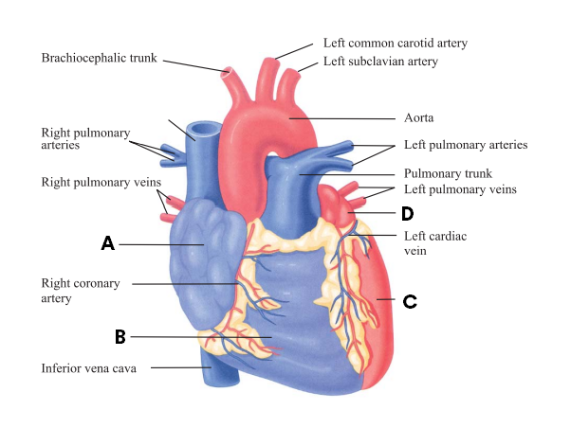
What does A represent in the given diagram?
A. Right atrium
B. Right Ventricle
C. Left atrium
D. Left Ventricle
ANSWER: A

What does B represent in the given diagram?
A. Right atrium
B. Right Ventricle
C. Left atrium
D. Left Ventricle
ANSWER: B

What does C represent in the given diagram?
A. Right atrium
B. Right Ventricle
C. Left atrium
D. Left Ventricle
ANSWER: D


What does D represent in the given diagram?
A. Right atrium
B. Right Ventricle
C. Left atrium
D. Left Ventricle
ANSWER: C
The ________circuit, which circulates blood through the lungs
A. Pulmonary
B. Systemic
C. Both A and B
D. None of these
ANSWER: A
The _____________circuit, which circulates blood to all other parts of the body
A. Pulmonary
B. Systemic
C. Both A and B
D. None of these
ANSWER: B
The path of blood through the lungs can be traced as follows
A. Left atrium receives oxygenated blood from the lungs through pulmonary veins, from the left atrium the blood flows into the left ventricle
B. Left atrium receives deoxygenated blood from the lungs through pulmonary veins, from the left atrium the blood flows into the left ventricle
C. Right atrium receives oxygenated blood from the lungs through pulmonary veins, from the left atrium the blood flows into the left ventricle
D. Right atrium receives oxygenated blood from the liver through pulmonary veins, from the left atrium the blood flows into the left ventricle
ANSWER: A
The _______bring deoxygenated and open into the right atrium
A. Superior vena cava
B. Inferior vena cava
C. Superior and inferior vena cava
D. None of these
ANSWER: C
Pulmonary circulation moves blood between:
A. The heart and the rest of the body
B. The heart and the lungs
C. The heart and the liver
D. The lungs and the brain
ANSWER: B
The pulmonary arteries carry:
A. Deoxygenated blood
B. Oxygenated blood
C. Both A and B
D. None of these
ANSWER: A
The pulmonary veins carry:
A. Deoxygenated blood
B. Oxygenated blood
C. Both A and B
D. None of these
ANSWER: B
Systemic circulation moves blood between
A. The heart and the rest of the body
B. The heart and the lungs
C. The heart and the liver
D. The lungs and the brain
ANSWER: A
The largest artery in the systemic circuit is the
A. Superior venae cava
B. Inferior venae cava
C. Aorta
D. Pulmonary vein
ANSWER: C
The largest veins are the:
A. Superior venae cava
B. Inferior venae cava
C. Aorta
D. Superior and inferior venae cava
ANSWER: D
The path of systemic blood to any organ in the body begins in the left ventricle which pumps blood in the
A. Superior venae cava
B. Inferior venae cava
C. Aorta
D. Pulmonary vein
ANSWER: C
___________supply blood to the heart muscle
A. Superior venae cava
B. Inferior venae cava
C. Coronary arteries
D. Aorta
ANSWER: C
The heart is located in the
A. Abdominal cavity
B. Coelomic cavity
C. Thoracic cavity
D. None of these
ANSWER: C
The heart is located between the
A. Kidneys
B. Liver
C. Lungs
D. Adrenal glands
ANSWER: C
The heart, trachea, esophagus and associated structures form a middle portion called the
A. Thorax
B. Abdomen
C. Mediastinum
D. Cavity
ANSWER: C
The heart lies deep and obliquely in the mediastinum and slightly to the left of the
A. Scapula
B. Humerus
C. Sternum
D. Femur
ANSWER: C
The _______of the heart deep to the sternum extends to the second intercostal space and the ________of the heart is in the fifth intercostal space, approximately 9 cm to the left of the midline
A. Apex, base
B. Base, apex
C. Bottom, top
D. None of these
ANSWER: B
The pericardium is a closed sac that surrounds:
A. Lungs
B. Kidney
C. Heart
D. Liver
ANSWER: C
Pericardium consists of
A. One part
B. Two parts
C. Four parts
D. Five Parts
ANSWER: B
The _________of the Pericardium consists of inelastic white fibrous tissue.
A. outer part
B. inner part
C. Both A and B
D. None of these
ANSWER: A
The ________of the Pericardium is made up of two membranes.
A. outer part
B. inner part
C. Both A and B
D. None of these
ANSWER: B
________reduces the friction between the heart wall and surrounding tissues when the heart is beating
A. Pericardial fluid
B. Matrix
C. Plasma
D. Fluid
ANSWER: A
The inelastic nature of the ________as whole prevents the heart from being overstretched or overfilled with blood pericardium
A. Pleura
B. Pericardium
C. Parietal pleura
D. Periosteum
ANSWER: B
_______________is a muscular pumping organ
A. Heart
B. Kidney
C. Lungs
D. Brain
ANSWER: A
The heart is _______________in shape
A. Oval
B. Conical
C. Spherical
D. Round
ANSWER: B
_______ reduces friction between walls of heart
A. Pericardium
B. Pericardial fluid
C. Atria
D. Ventricle
ANSWER: B
The heart is covered by a membrane called
A. Epidermis
B. Dermis
C. Epicardium
D. Pericardium
ANSWER: D
The ________is located in the thoracic cavity between the lungs.
A. Kidney
B. Heart
C. Brain
D. Ureters
ANSWER: B
The ___________ and associated structures form a middle portion called mediastinum
A. Heart
B. Trachea
C. Oesophagus
D. All of these
ANSWER: D
The heart lies deep and obliquely in the mediastinum and slightly to the ________of the sternum
A. Right
B. Left
C. Front
D. Back
ANSWER: B
The pericardium is a closed sac that surrounds
A. Kidney
B. Heart
C. Brain
D. Ureters
ANSWER: B
Pericardium consists of
A. Out Part
B. Inner Part
C. Both A and B
D. None
ANSWER: C
The ________reduces the friction between the heart wall and surrounding tissues when the heart is beating
A. Pericardium
B. Matrix
C. Stroma
D. Pericardial fluid
ANSWER: D
____________is an inflammation of the pericardium
A. Pericarditis
B. Arthritis
C. Hepatitis
D. Ureteritis
ANSWER: A

The _________is supplied with blood by the right and left coronary arteries
A. Pleura
B. Myocardium
C. Glomerular basement membrane
D. Zona glomerulosa
ANSWER: B
The anterior cardiac veins drain directly into the
A. Right atrium
B. Left atrium
C. Left ventricle
D. Hilum
ANSWER: A
Arterial blood enters the kidney at the ___________through renal artery
A. Calyx
B. Papilla
C. Hilum
D. Cortex
ANSWER: C

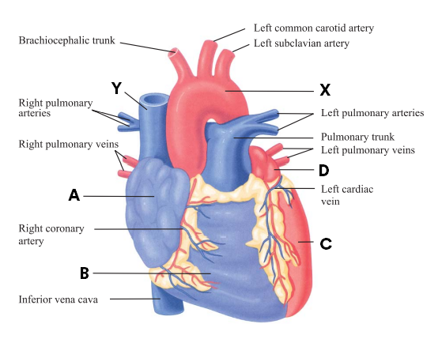
What does Y represent in the given diagram?
A. Superior vena cava
B. Aorta
C. Inferior vena cava
D. Tricuspid valve
ANSWER: A
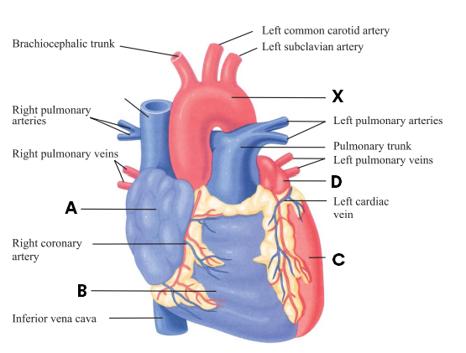
What does X represent in the given diagram?
A. Superior vena cava
B. Aorta
C. Inferior vena cava
D. Tricuspid valve
ANSWER: B

